 | descripton | image | condition
1 | George Wostenholm I-XL Canoe | 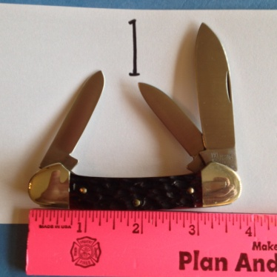 | New
2
3 | Bone USA Pen | 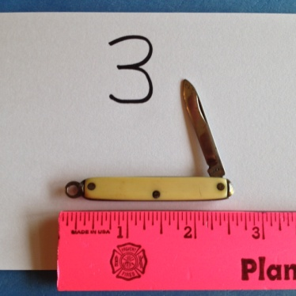 | Poor
4 | Browning Lock Blade Clip | 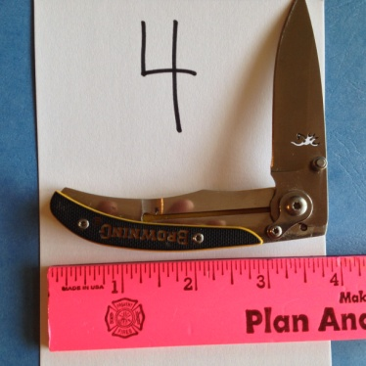 | Good
5 | Barlow Mutmaster Utiga NY USA | 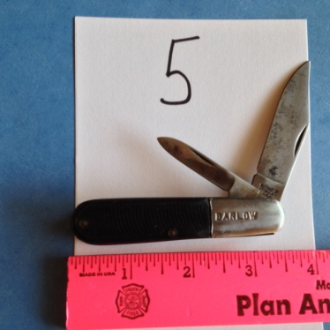 | Good
6 | Sears Craftsman | 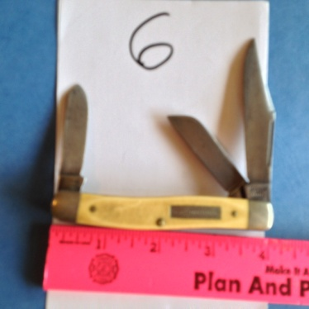 | Poor
7 | Sabre Deer Lock blade | 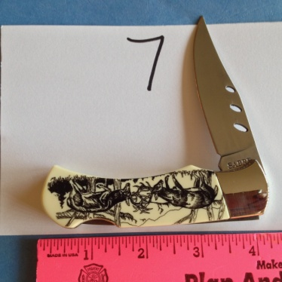 | New
8 | Kershaw 12 GA | 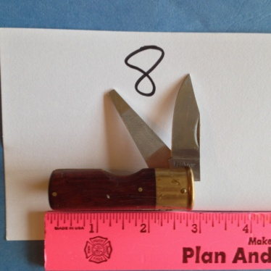 | Poor
9 | Schrade FFA Farmers Pride Special Edition | 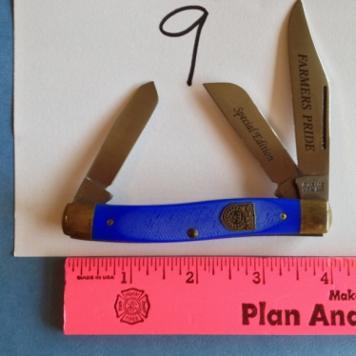 | good
10 | Victorinox DWF Wholesale Florists | 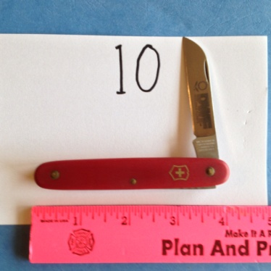 | good
11 | 007 Lock Blade | 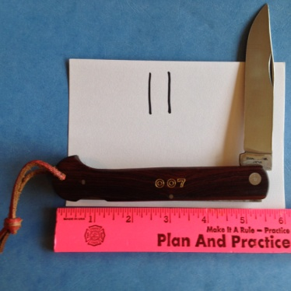 | good
12 | Black Folding lock Stiletto | 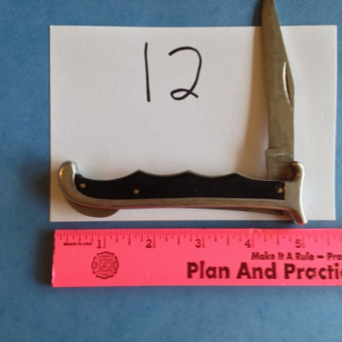 | poor
13 | Pearl Folding lock Stiletto I.C.M. Italy | 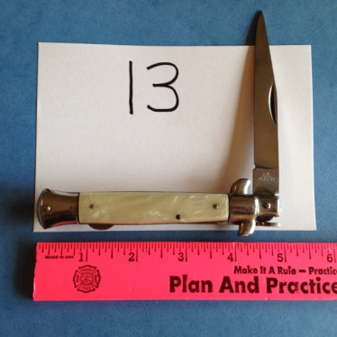 | good
14 | Stag Ireland Fish Knife | 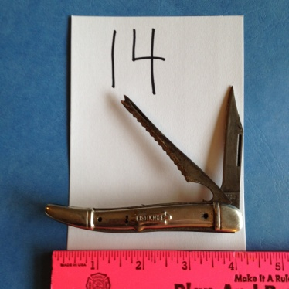 | poor
15 | Schrade 598? | 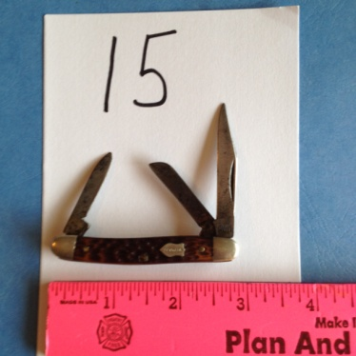 | poor
16 | Gerber Gun Metal Lock Blade Clip | 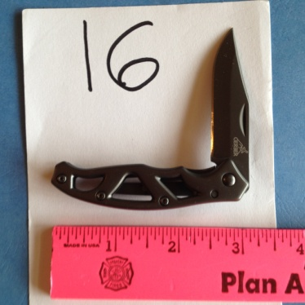 | new
17 | Uncle Henry Scrade 227UH | 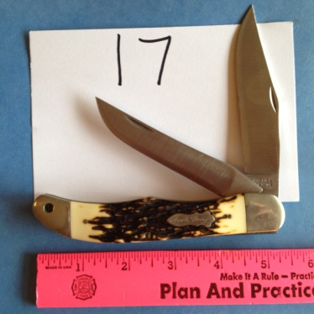 | Good
18 | Case XX Slimline Trapper | 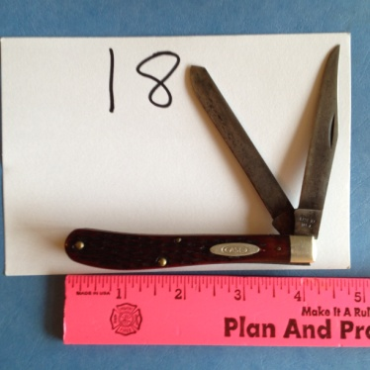 | Poor
19 | Gerber Matte S/S Lock Blade Clip | 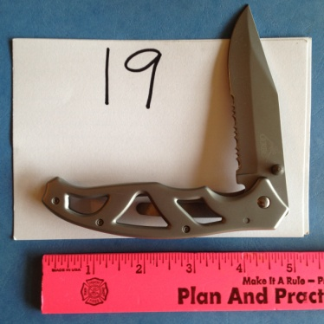 | New
20 | Richards & Conover Hdwe co 411vintage folding knife Bone | 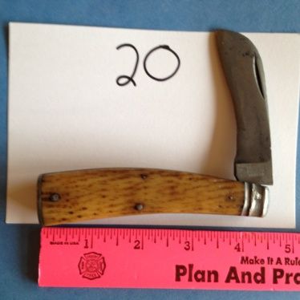 | Poor
21 | Oscar Barnet Tool Co Newark New Jersey Plier Knife HHH (stamped SP) | 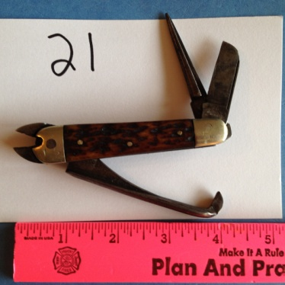 | good
22 | CaseXX Canoe 62131 CV | 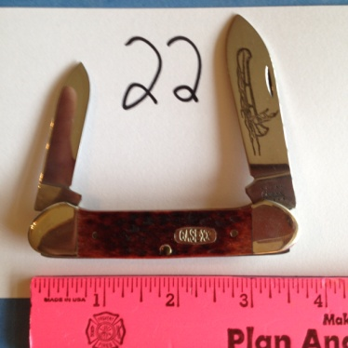 | New
23 | Case XX 5318 SS | 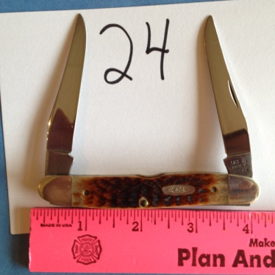 | New
24 | case XX MUSKRAT BRADFORD pa !992 |  | New
25 | Case XX 6265 -SAB | 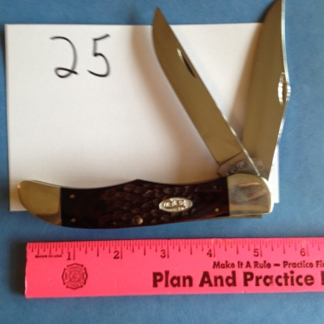 | New
26 | Buck 186 C Lock Blade Clip | 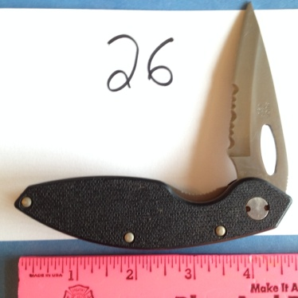 | New
27 | Schrade Ltd IHEA (International Hunter Education Association) | 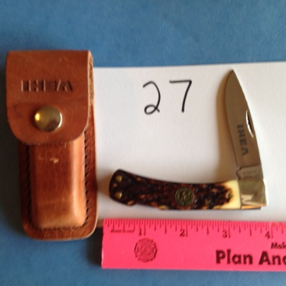 | New
28 | Schrade Old Timer Pro Hunter | 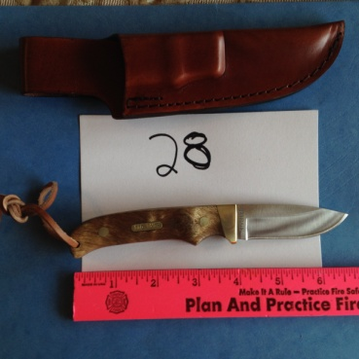 | New
29 | Schrade Handmade Limited Issue 2009 (horse) | 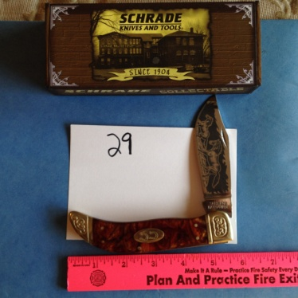 | New
30 | Schrade Handmade SCLD (deer) | 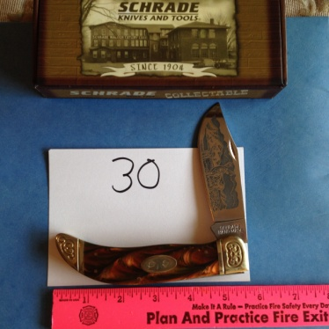 | New
31 | Schrade Old Timer 10" Bowie | 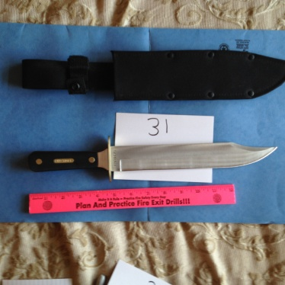 | New
32 | Puma Lieutenant 230260 104/RC Lock Blade | 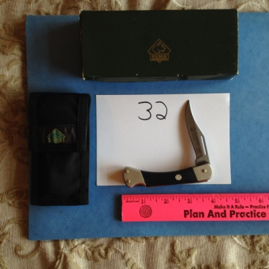 | New
33
34 | Puma General 230270 105/RC Lock Blade | 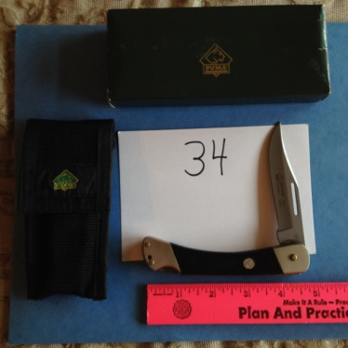 | New
35 | Lot of 6 folding Key chain, etc.. Knifes | 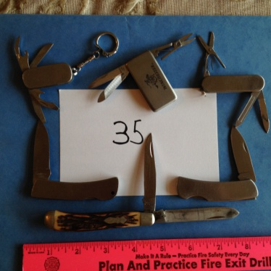 | Poor
36
37
38 | Case XX #00786 Stockman PW Ored6318SS 021205007861 | 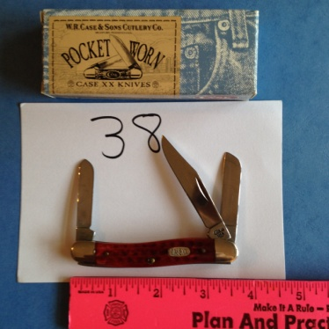 | New
39 | Case XX #00789 4 BLD PKT WRN 64052SSM Module 2 021205007892 | 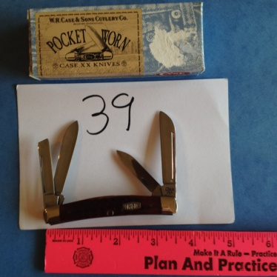 | New
40 | Kershaw Limited Edition 1993 Black Micarta handle and Brass Bolster Lock Blade | 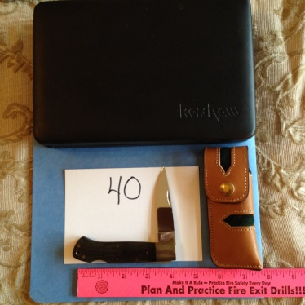 | New
41
42 | Scrade SP 3 GM Goodwrench | 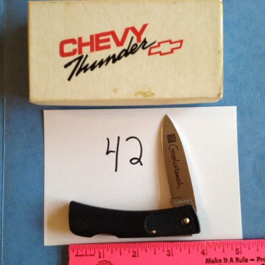 | New
43 | Sheffield Multi purpose tool 12301 camper | 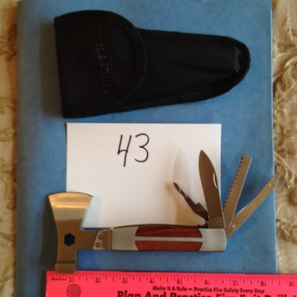 | New
44 | Winchester 2004 3pc Limited Edition set | 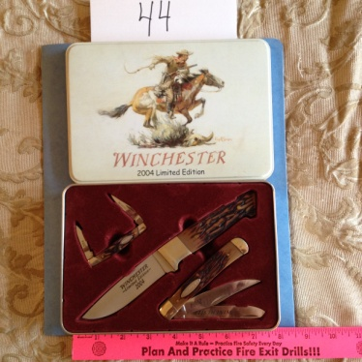 | New
45 | Buck 560 lock blade (Black) | 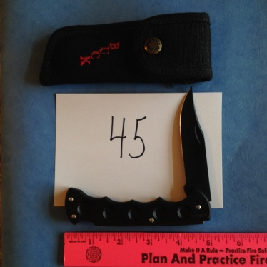 | New
46 | Case XX SS 53033 | 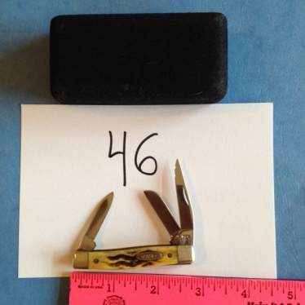 | New
47 | Frost Cutlery Steel warrior Muskrat sw-122wsbda | 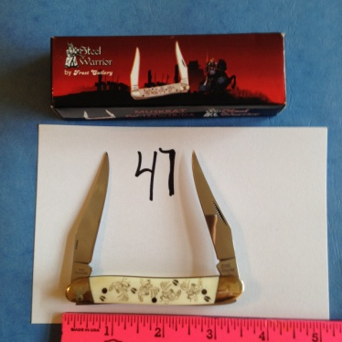 | New
48 | 5 assorted wet stones | 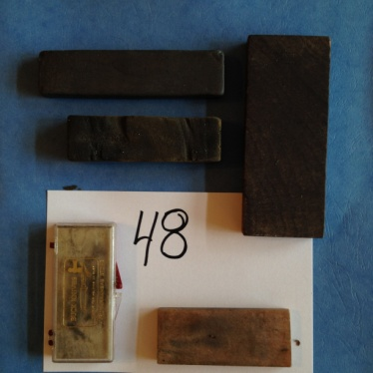
49 | Buck CrossLock 0180-S1-0 033753022609 Lock Blade | 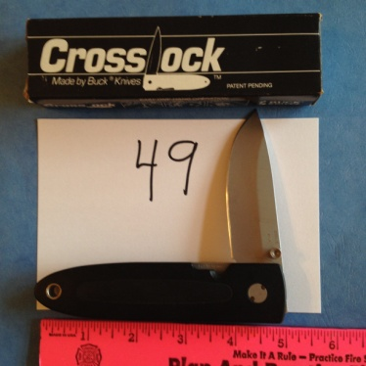 | New
51 | New | 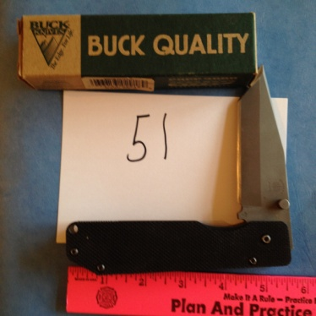 | New

